Developing a web application to improve communication at a software company.

**E. Dreyer**

Research methodology for the Dissertation submitted in partial fulfillment of the requirements for the degree *Bsc in Information Technology Hons* at the Vaal Campus of the North-West University

Supervisor: Dr. Suné Van Der Linde

Co-supervisor: Mr. Luke Coetzee

Date of submission: 2021/05/12

Version: 1.0

Table of Contents

LIST OF ABBREVIATIONS ii

Chapter 5: Data Gathering and Analysis 1

1. Introduction 1

2. Problem description and background 1

3. Aims and objectives of project 1

4. The Artefact Design 2

4.1. Summary of feedback 2

4.2. Artefact design 3

4.2.1. Improve communication 4

5. Conclusion 7

6. Reference List 7

LIST OF ABBREVIATIONS

EU European Union (Abbreviation)

List of Figures

**No table of figures entries found.**

List of Tables

**No table of figures entries found.**

Chapter 5: Data Gathering and Analysis

# Introduction

The goal of this study is to develop a web application that can be used to enhance communication between developers and management at a South African software development company. As discussed in Chapter 2, this study follows the Vijay Vaishnavi (2004) process model, this chapter will focus on the “Development” phase. This chapter is the end of the initial section of the process model and the beginning of production.

# Problem description and background

In the corporate world, businesses rely on effective communication to succeed. Developers use their screens to communicate and to develop, it often happens that developers lack the number of screens that they need to keep all their important tabs open. This makes it harder for important messages to reach developers and influences productivity and creativity (Schrader, 2018).

As a solution, an artefact has to be developed to assist with the effectiveness of communication in the industry.

# Aims and objectives of project

This study proposes the development of a communication web application that can easily be viewed in an office by all employees to allow easy access to important communication regarding specific software development projects. Where the primary objective is to develop a web application for a South African software development company that allows for easy access to important communication relating to specific project.

This chapter will discuss the feedback that was obtained by the interview discussed in Chapter 4.

# The Artefact Design

## 4.1. Summary of feedback

The design of the artefact has to satisfy the requirements as set out in Chapter 4, the suggestion phase. Along with the requirements and specifications, the artefact also followed the Human-computer interaction rules to provide the best user experience as discussed in Chapter 3 of this study.

The conclusion was that the artefact should improve both communication and productivity in the company. To achieve this the artefact should not only focus on communication between employees, but also communicate the information about the project. The artefact should create a more relaxed environment in the company, while making it easier for the users to interact with the communication aspect that is required in the industry.

Table 4.1. below shows the requirements or specifications and how it will be solved with the use of the built artefact.

1. Table 4.1: Most important requirements and specifications

|  |  |  |
| --- | --- | --- |
| **Most important requirements and specifications** | | |
| **#** | **Requirement or specification** | **How it is solved in the artefact** |
| 1. | Improve communication. | Combine different methods of communication as discussed in Chapter 2 of this study. For the Artefact the focus was on instant messages and Issue queues. |
| 2. | Improved productivity. | For a project overview, a user will be able to see feedback on if the other users in their team are busy or not. The artefact also provided clear instructions and users know exactly wat is expected from them. |
| 3. | Artefact should focus on communication between employees and communication about the project. | Not only can users communicate with each other, but they can also get the necessary information about their project. |
| 4. | Create a relaxed environment. | The artefact allows for automatic data capture. A calendar system was also added to allow users to organize their activities better. |
| 5. | The user experience comes first. | By using pre-emptive dialog, users will make minimal errors when working with the artefact. Other features can be added if a user desires such a feature. |

## 4.2. Artefact design

The design of the artefact is based on the most important requirements and specifications shown in Table 4.1. The next section of the study will visually explain the design of the artefact with the use of screenshots.

### Improve communication

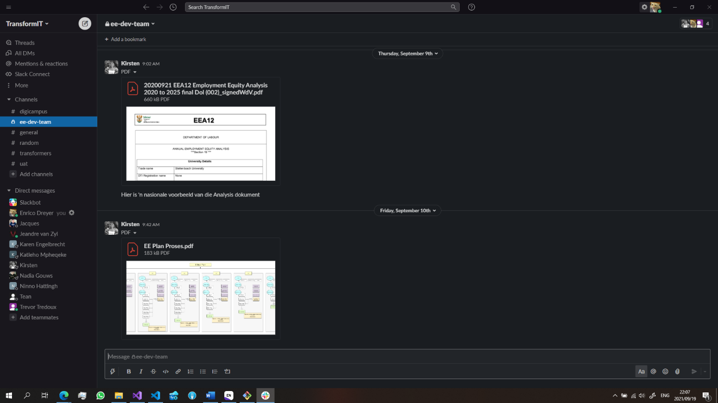

Figure 1: Instant messages

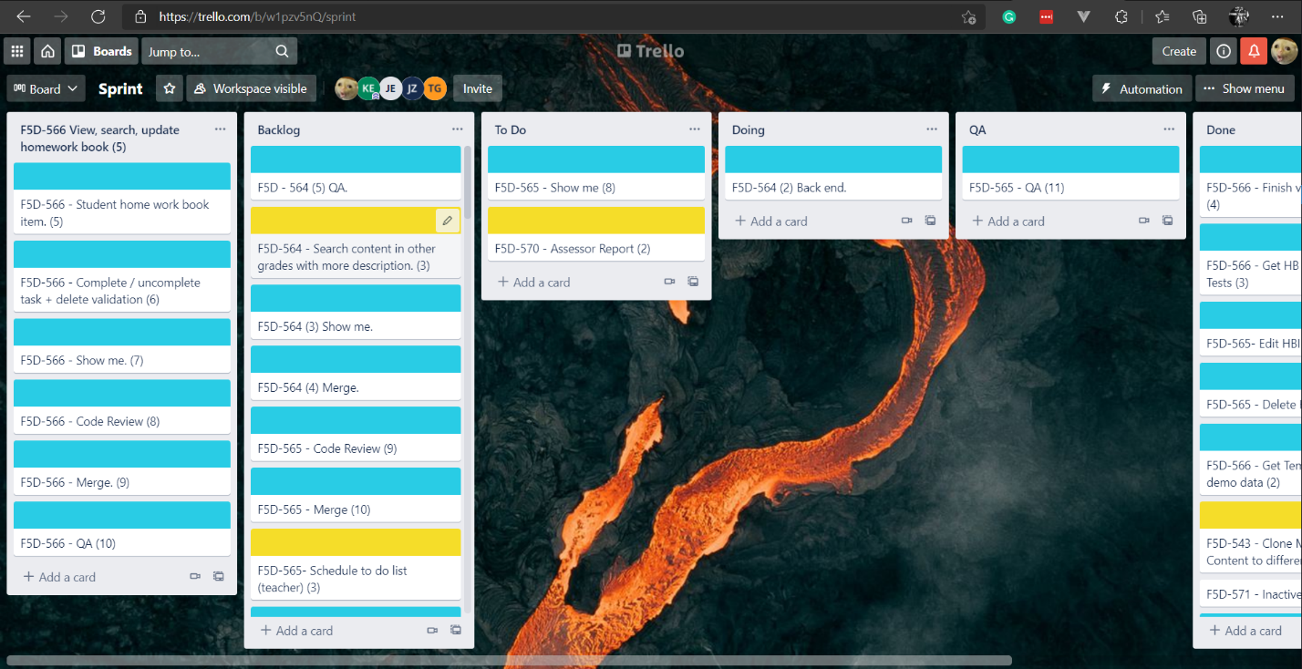

Figure 2: Issue queues

The two ways that the artefact allows communication between employees is making use of instant messages and issue queues. Instant messages allow the employees to communicate directly to each other, whereas issue queues focus more on the tasks that they are busy with.

### Improve productivity

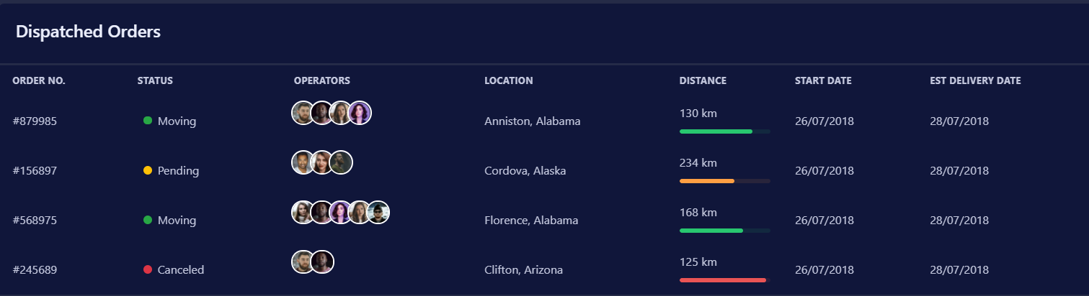

Figure 3: Team detail

Figure 3 displays information on the whole team and what they are busy with.

### Focus on both communication between employees but also about project

Figure 4: Project statistics

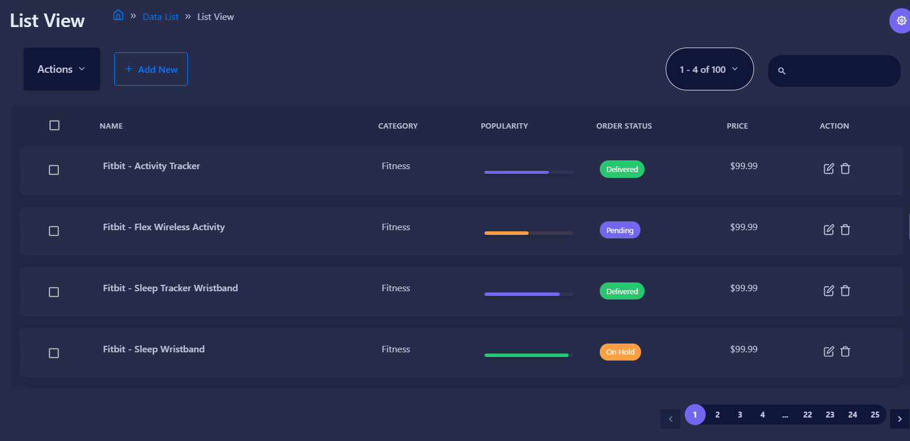

Figure 5: Project Detail

Figure 4 shows project statistics while Figure 5 shows detail on the project that the team is busy with.

### Create relaxed environment

Figure 6: Calendar

Figure 6 shows the users calendar where they can add or edit events.

### User Experience comes first



Figure 7: Guidelines for the user

Figure 7 shows dialog from the artefact, this allows for ease of use of the artefact.

# 5. Conclusion

The focus of this chapter was the development phase of the Vijay Vaishnavi (2004) process model. Along with the requirements and specifications gathered from the interview as discussed in Chapter 4, the development of the artefact made use of the human-computer interaction rules as discussed in Chapter 3. This chapter also included screenshot of the artefact to explain how the artefact solved the requirements and specifications.

# 6. Reference List

Schrader, J. (2018, 30 July). *How Your Cell Phone Habits Impact Your Productivity*. <https://www.psychologytoday.com/us/blog/why-bad-looks-good/201807/how-your-cell-phone-habits-impact-your-productivity>

Vijay Vaishnavi, B. K., and Stacie Petter. (2004). DESIGN SCIENCE RESEARCH IN INFORMATION SYSTEMS. 62. <http://desrist.org/design-research-in-information-systems/>